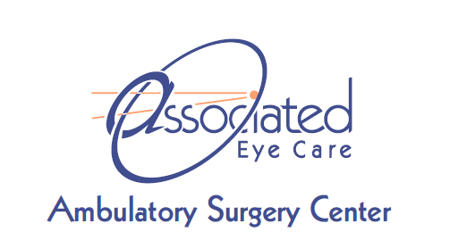

Precertification Policy
I understand that any requirement for completion of insurance precertification is MY responsibility. AEC will assist with precertification but will not assume responsibility for precertification or any impact that it may have on insurance payments.

Statement to Permit Payment of Facility and Medical Insurance Benefits
I authorize insurance benefits, payable on my behalf or otherwise payable to me, to be paid directly to AEC. I authorize physician benefits, payable on my behalf or payable to me, to be made to the physician(s) responsible for my care. I understand that I am responsible for any charges not covered by this assignment. I authorize AEC to release information required by my insurance company and/or health plan to file a valid claim for payment for my procedure.

Payment for Care
I (the patient or the undersigned custodian) am financially responsible for any deductible, co-payment, and all charges for services or goods not paid for by health care benefits, plans, or entitlements. The undersigned agrees to pay to AEC all amounts due in consideration of services and supplies rendered to the patient by the facility. Charges for services or goods will be at AEC's billed charge rates unless otherwise agreed to by AEC in advance.

Physician Ownership of Facility
I understand that the following physicians partially and beneficially own AEC and the Ambulatory Surgery Center, a Minnesota for-profit corporation: Alan Downie, M.D., Adam Goddard, D.O., Jeffrey Lynch, M.D., David Park, M.D., Susan Schloff, M.D., Gary Schwartz, M.D., Brian Tienor, M.D., Jesse Vislisel, M.D., and Charlie Wu, M.D.

